When you first pull it up you get the screen below:
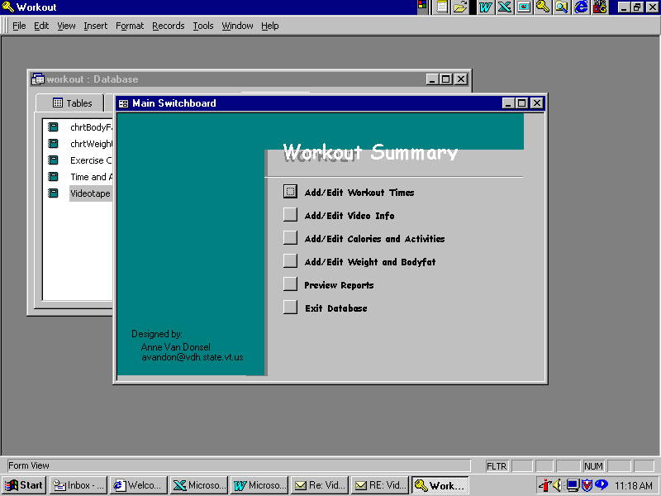

Then there are forms for adding workout times – there are drop down menus so you can select from the videos and activities you’ve entered.
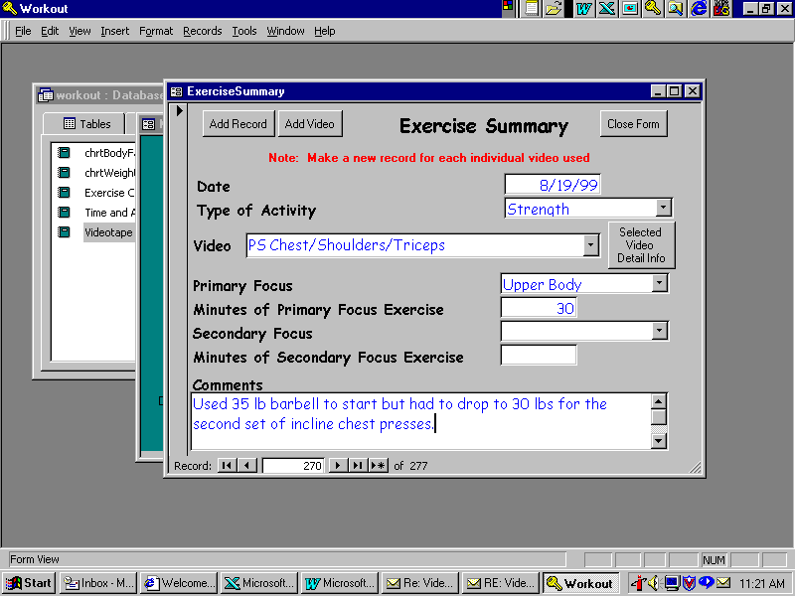

And forms for adding tapes:

Form for adding tapes tapes:
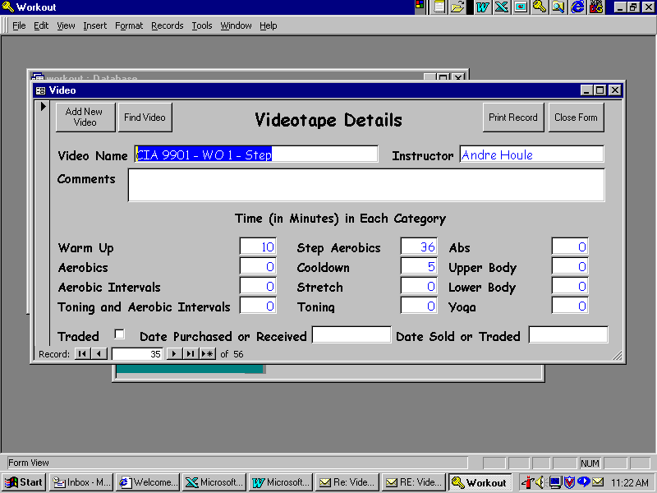

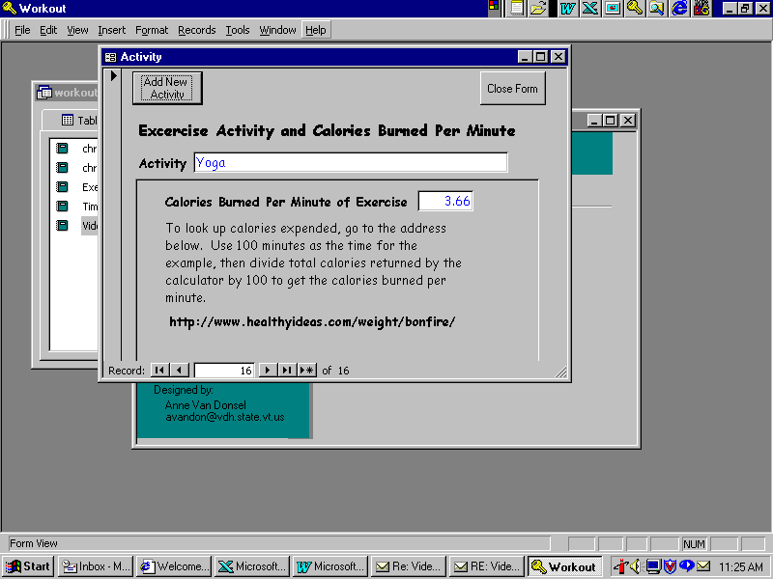

And a place to track weight and bodyfat – this could be modified to include measurements:

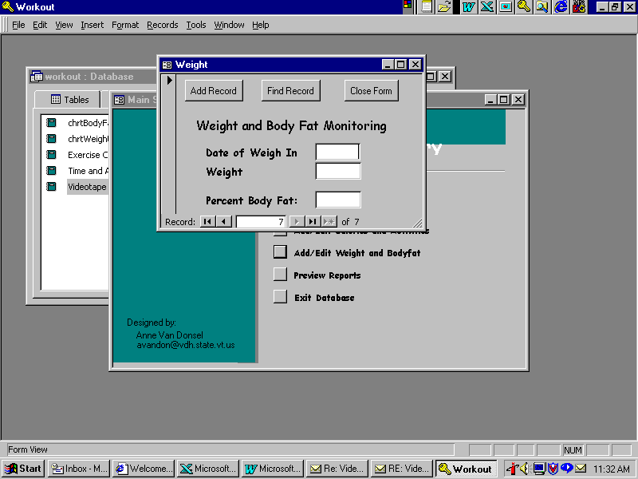

A place for adding activities and calories:

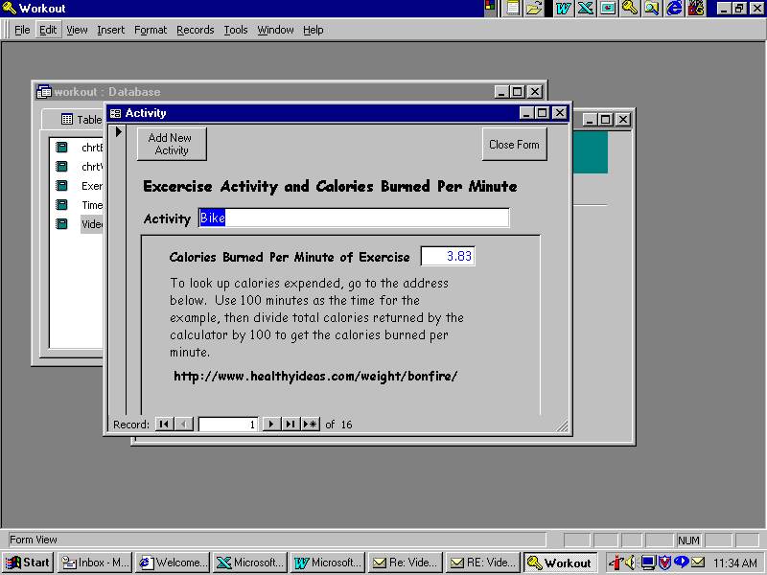

Then I have a whole series of reports that I can choose—here is the menu of reports.
